Setting up Your Club Pages: a Guide for Club Owners

Table of Contents

Introduction

An Overview of your Working Environment 3
Editing the Wrapper for your Pages 5
Selecting a Layout 5
Setting the Wrapper Width 6
Editing the Top Navigation Links 6
Selecting a Photo 7
Adding a Photo 7
Replacing or Deleting a Photo 9
Editing the Page Headings 10
Formatting the Home Page 12
Adding Additional Pages 16
Adding an Event Page 16
Adding a News Page 20
Adding a Photo Page 22
Adding an “Other Page” 26
Editing Pages 29
Deleting Pages 29
Adding and Editing Links 31
Adding a Link 31
Editing a Link 32
Deleting a Link 33
Managing Membership Information 34
Managing Email Signup 38
Managing Contact Information 41
Going “Live” with your Club Pages 43
Sending an Email 44
Managing Mailing Lists 46
Creating a New List 46
Editing a List 48
Deleting a List 48
Editing the Unsubscribe List 48
Running a Membership Report 49
Uploading Documents 49
Editing the Documents Page 50
Uploading a Document 51
Testing the Upload 53
Viewing or Searching the Document List 54
Deleting a Document 55
Using a Web Log 55
Creating a Web Log 55
Posting a New Topic to a Web Log 57
Posting Additional Comments to a Topic 60
Removing a Comment 61
Deleting a Lob 62
Adding a Video 62
Adding (and Deleting) RSS Feeds 63
Integrating with PayPal 67

For use with Convio Club Pages™
September, 2010
Setting up Your Club Pages
Congratulations! You have been selected to manage the web pages for your club. Your view of the club pages is very similar to that of your general membership—except that you have some additional links that allow you to design the look of your site and add and edit the material on your pages. You—and any other members of the owners group for your club—are also the only members who will be able to send email to your membership.
These directions will step you through the process of setting up your site. You will begin by editing the “wrapper” for your site—choosing the headings for your club activities and the general layout of your pages (if you have custom layouts available). You may also add an image to the wrapper. Next, using the templates provided, you will select a font and color scheme for your Home Page, adding an image if you choose. After adding your own content to complete the Home Page, you can go on to design pages for your other activities. (All these additional pages will automatically be linked back to the Home Page for your club.) You will be able to make changes to your pages at any time simply by selecting the page and choosing the Edit this Page link. You will also be able to make changes to your Membership and Contact information pages in the same way.
When you have finished building your club site, you should contact the site administrator(s) for your sponsoring organization so that they can publish your site and provide a link to your club from their main pages. You can continue to add (or remove) pages and make changes to existing pages whenever you need to. Your viewers will always see the last saved version of your pages.

An Overview of your Working Environment
You will receive an email from the site administrator for your sponsoring organization when your club pages are ready for design. Click the link for the pages that is supplied in the email and use your password and user name to log in. Your first view of your club pages should be something like the following:
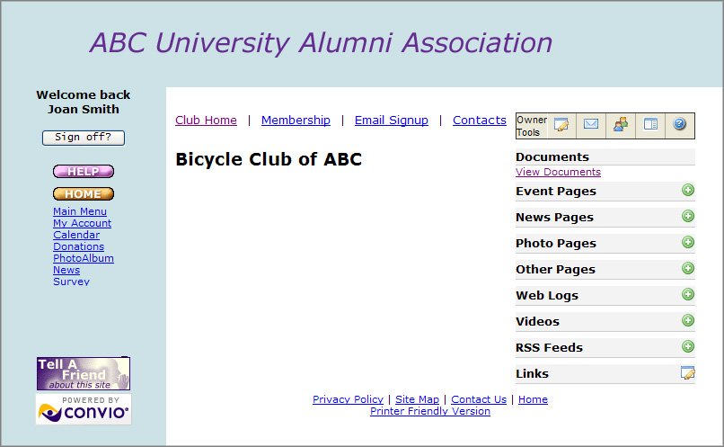
Wrapper area for your club pages

This opening page is the home page for your club. Note that you have the following links available:
Club Home – a link for your club’s home page; available to both owners and members from all pages
Membership – available only if your club has chosen to use a form for membership; if present, the link is available to both owners and members although only owners can modify the contents
Email Signup -- available to most clubs to allow site visitors to register for email; informational text on this page can be edited by club owners (note that this feature may be disabled for some organizations)
Contacts – leads to contact information for your club; available to both owners and members although only owners can modify the contents
In addition, as an owner, you also have access to the following Owner Tools:

Tool | Function | Description
 | Help me get started | Leads to this document; available only to owners
 | Edit the Wrapper for All Pages | Allows you, as the owner, to design the static area that surrounds the content that will change; includes page headings, an optional photo, and, in some cases, layout options (not to be confused with the wrapper for your sponsoring organization which will surround all your club pages)
 | Edit This Page | Enables you to edit the currently displayed page
 | Send Email | Enables you to send email to your club members, club owners, subscribers list, and any other lists permitted by your organization; note that this tool may not be present until after you have notified your parent organization that you are ready to go live with your pages
 | Manage Mailing Lists | Enables owners to create a new mailing list, edit the unsubscribe list, and run a Membership Report
 | Add Pages | Enables owners to add pages to any of the corresponding topics where this icon is present – such as Events, News, and Photos

The Links item at the bottom of the Topic list -- with the corresponding icon – allows you to add and edit links to other sites.
Begin now by designing your page wrapper.

Editing the Wrapper for your Pages
Before you begin to add content, you should determine the general format for all your club pages: what your general headings will be, and what the layout will be for the headings and space that surround them (if you have custom layouts available). We refer to this area as the “page wrapper”—the space that remains the same on every page and wraps around the dynamic content. You can also choose to include a photo on your wrapper, if you like.
Edit your club wrapper as follows:
Selecting a Layout
Important: You will only have this layout option if you have custom layouts available; the font and color scheme of the wrapper will automatically follow the style of the individual pages for a homogeneous look.
To select a layout:
- Select the icon on your home page to open the editing page for the wrapper.
- In the upper portion of the editing page, select a layout for your wrapper using the drop-down menu, if one is available.
Note: If your screen appears like the one in the following illustration where no layout option is available, skip on to “Editing the Wrapper Width”, "Selecting a Photo", or "Editing the Page Headings" to learn how to make changes to those portions of your wrapper.

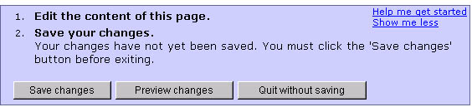
The Layout option will be available in this portion of the window if you have custom layouts available.

- Click Preview changes to see what your wrapper will look like with the selected layout.
- Try other layouts if you wish, clicking Refresh Preview after each change.
- When you are satisfied with your layout, click Edit the content of this page to return to the editing page for the wrapper.
- If you do not wish to add a photo to your wrapper, and/or change the page headings or navigation Link text, click Save Changes and then click Stop editing this page to return to the opening window (the home page); otherwise, continue on with those sections now.
Setting the Wrapper Width (Optional)
If you would like to set the width of the right-hand portion of your Club wrapper (the portion with the optional photo and links to your events, news, photos, and so forth) so that it allows an optimal display area for your articles, you can do so in the Properties area on the wrapper editing page.
Important: If you do not set a pixel width for the right-hand portion of your wrapper, it will default to the width of any image you add, with a minimum width of 200 pixels.
To set the page wrapper width:
- In the Properties section on your page wrapper editing page, enter the Width in Pixels for the right-hand portion of your wrapper.
Tip: We recommend a width somewhere between 150 – 250 pixels. You may want to set it initially to 200 pixels, and then return to “tweak” it after adding additional content.
- Click Preview changes to see what your wrapper will look like with the width that you entered.
- Try other widths if you wish, clicking Refresh Preview after each change.
- When you are satisfied with your width, click Edit the content of this page to return to the editing page for the wrapper.
- If you do not wish to do any further editing of your wrapper, click Save Changes and then click Stop editing this page to return to the opening window (the home page); otherwise, continue on with the following sections now.
Editing the Top Navigation Links (Optional)
You can modify the text for the Top Navigation Links, if you choose. For example, you could change the “Email Signup” link so that it reads simply “Signup.”
To edit the Top Navigation Link text:
- In the Top Navigation Links section of your page wrapper editing page (near the top of the page), enter new text for any link you would like to modify.
- Click Preview changes to see what your wrapper will look like with the width that you entered.
- Try other text changes if you wish, clicking Refresh Preview after each change.
- When you are satisfied with your changes, click Edit the content of this page to return to the editing page for the wrapper.
- If you do not wish to do any further editing of your wrapper, click Save Changes and then click Stop editing this page to return to the opening window (the home page); otherwise, continue on with those sections now.
Selecting a Photo (Optional)
Note: These directions are optional at this point—depending on whether you want to include a photo on the wrapper for your site. However, the directions describe the standard way to add a photo to your site and we will refer back to these directions again when discussing how to add a photo to the Home Page and how to add photos to an album. Photos for all pages must be in JPEG (.jpg) format and can be up to 4MB in size.
Adding a Photo
If there is no photo currently selected, add a photo to your wrapper, page, or album as follows:
- In the Photo portion of the editing page for your wrapper (shown below), click the Browse button.

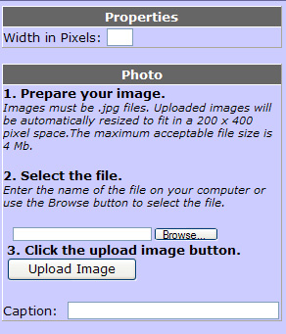

- In the dialog box that opens, navigate to the photo you want to include.

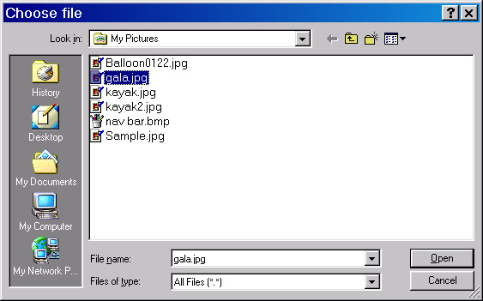
Navigate to your photo
Select the photo
Click Open

- Select the photo and click Open. The file path for the photo should now appear in the original Browse field.
- Click the Upload Image button. The photo itself should now appear in the window.
- Provide a Caption for the photo if you would like.
- Click Preview changes in the upper portion of the editing page to view the photo, as it will appear on your finished page. Your Preview window should look something like the following:

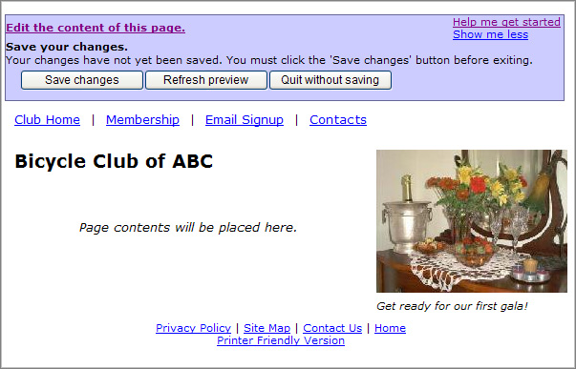

- Click Edit the content of this page to return to the editing page for the wrapper. If you want to change or delete the photo, see the directions below.

Replacing or Deleting a Photo
If you don’t like the photo you have placed on your wrapper (or page), you have two choices—both accessed from the Photo pane of the editing page as shown below:

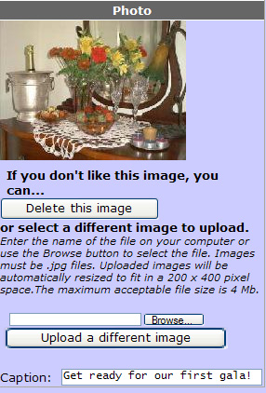

- Click Delete this image. The image will disappear and the Photo dialog pane will return to the original configuration—as if you had never added an image.
Or,
- Click the Browse button to locate and Open a new image and then click the Upload a different image button. This technique will substitute a new image for the old one. Don’t forget to change the Caption (if you had one) and Preview the new results.

Editing the Page Headings (Optional)
You can change the page headings on your wrapper if the standard headings do not reflect the activities of your club. You can also determine how many links you will display on the home page beneath each Page heading, and also determine the sort order when multiple links display under each heading.
Important: Since page headings that do not contain any content do not display in preview mode (nor do they display to members), it may be difficult initially to verify your changes. You may want to review this section and then return to it once you have more content to view.
To edit the page headings:
- In the lower portion of the editing page for the wrapper, change the headings for related pages, if you like. For example, if you are a Bicycle club, you might prefer to use the word “Races” rather than Events, or you might like an actual name for your “Other Pages”. Make changes by typing directly in the spaces provided. A portion of the pane for changing headings is shown below:

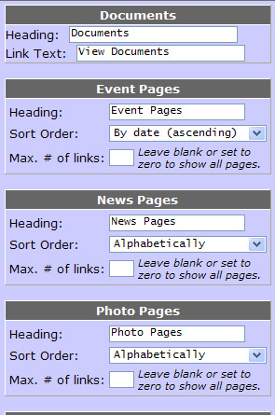

- If you have the Documents section available (at the top of the Page list), change the Link Text for viewing uploaded documents, if you wish.
- To change the Soft Order for any of the page types, select a new sort order from the corresponding drop-down menu. (Note that the Sort Order determines how multiple pages in any topic area will be displayed.)
- To limit the Number of Links that will be displayed on the Club Home page for any topic, enter the maximum number of links you will allow for that topic.
Important: Once the maximum number of links is reached, a View All link will appear to show the additional links on a new page.
- If you make changes, click Preview changes (in the upper portion of the editing page) to view your wrapper with the new headings.
Important: Remember that headings without corresponding content do not appear in the preview – not to your members.
- On the preview page, click Edit the content of this page to return to the editing mode if you would like to make more changes;
Or,
Click Save changes to accept the changes and then click Stop editing this page to return to the opening window (your home page).
Note: You can also Save changes directly from the editing page without previewing; however, this is probably not a good idea unless the change is minor – since the changes will be immediately visible to any Club members.

Formatting the Home Page
When you have completed the club wrapper and saved your changes, you should format the Home Page for your club. You will complete this task by (1) choosing a style for your font and color scheme, (2) adding an image (optional), and (3) providing your own content.
Format the Home Page as follows:
- In the upper right corner of your opening page (the home page), choose the Edit icon to open the editing page as shown below. (This link will take you to the editing page for whichever page you are currently viewing—in this case, the home page.)

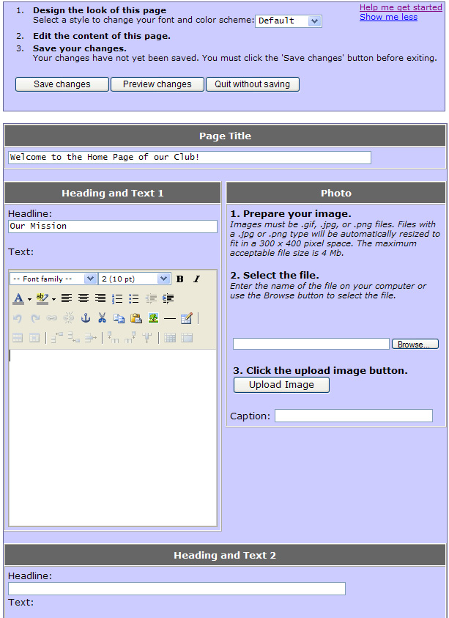
Select a Style
Select a Photo
Enter a Page Title
Enter a Headline and Text
Enter a second Headline and Text

- Choose a Style for your font and color scheme from the drop-down menu at the top of the page. (Choose the same style as that for your wrapper to maintain a consistent look.)
- Enter a Page Title—for example, “Welcome to our Home Page”—by typing directly in the space provided.
- (Optional) Select a Photo following the directions in the Photo pane of the editing page:
- Browse to locate and Open the image file
Note: Photos can be .gif, .jpg, or .png files. Files with a .jpg or .png type will be automatically resized to fit in a 300 x 400 pixel space. The maximum acceptable file size is 4 MB.)
- Upload the Image
- Provide a Caption
Note: See more complete directions for selecting a photo in the preceding section on editing the page wrapper.
- Provide your own content by typing directly in the Headline and Text boxes. (See Using the Tiny MCe Editor for help with the formatting features.)
- Click Preview changes to see what your page will look like. The preview might look something like the following:

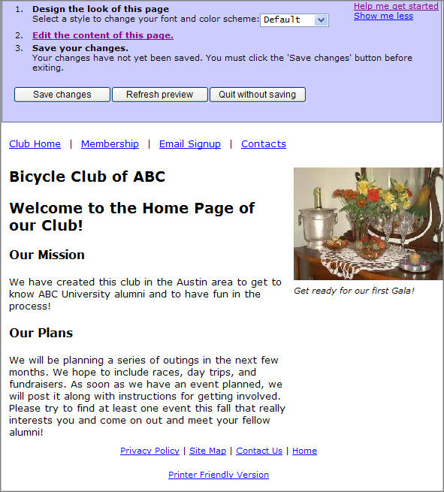

- On the preview page, click Edit the content of this page to return to the editing mode if you would like to make more changes;
Or,
Click Save changes to accept the changes and then click Stop editing this page to return to the opening window.
Note: As with the page wrapper, you can also click Save changes directly from the editing page and then choose Stop editing this page to return to the active page without previewing; however, use this technique only if you have decided not to make changes or if the change is very minor – since your members will see your changes immediately if your club is published.

Adding Additional Pages
You can add pages under any of the headings on your page wrapper simply by clicking the Add icon next to the heading and following the directions on the editing page that opens. This section will step you through the addition of pages under each of our standard headings: Events, News, Photo Pages, and Other Pages. (If you have renamed your headings, see the corresponding sections.) Note that Web Logs, Videos, RSS Feeds, and Links are treated separately in later sections.
You can add as many pages as you like under each heading.

Adding an Event Page
An Event page is similar to your Home page except that you can include dates. When the event date has passed, the page will automatically be removed. You can also choose to remove this page at any time (for example, if the event is sold out).
Note: The More Links version of Event Pages displays the events on a calendar and includes events that are in the past.
To set up an Event page:
- Click the Add Event icon next to the Event Pages heading on your page wrapper to open the editing page for events shown below:

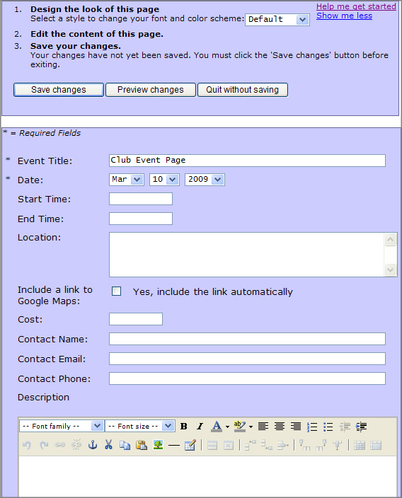

- Choose a Style for your font and color scheme from the drop-down menu at the top of the page.
- Provide a Title for your event.
Note: This title will appear on the event page and will also appear as a link on the page wrapper under the Event Pages heading; when the link is clicked, it will take members to your event page.
- Enter the Event Date using the drop-down menus provided for the Month, Day, and Year.
- Enter a Start Time and an End Time for the event.
- Provide the Location for the Event, including the full address if possible.
- If you have the Google Maps option (beneath the Location field), be sure to check that box if you would like to include a link to Google Maps—to help your members find the event location.
Important: If you are using the Google Maps feature, be sure to include the Zip Code in the location.
- Complete all the remaining details for the event—if you have them—by typing directly in the boxes provided. (See Working with the TinyMCE Editor if you need help with the editing tools in the Event Description section.)
- If you are using PayPal Integration, check the Yes, use PayPal box (not shown above) and complete the requested fields if you would like to use your PayPal account to collect fees for this event.
Note: The PayPal Integration fields will only appear if your parent organization has decided to make this option available. Most clubs will not see this option.
- Click Preview changes to view the proposed Event page. Your preview might look something like the following:

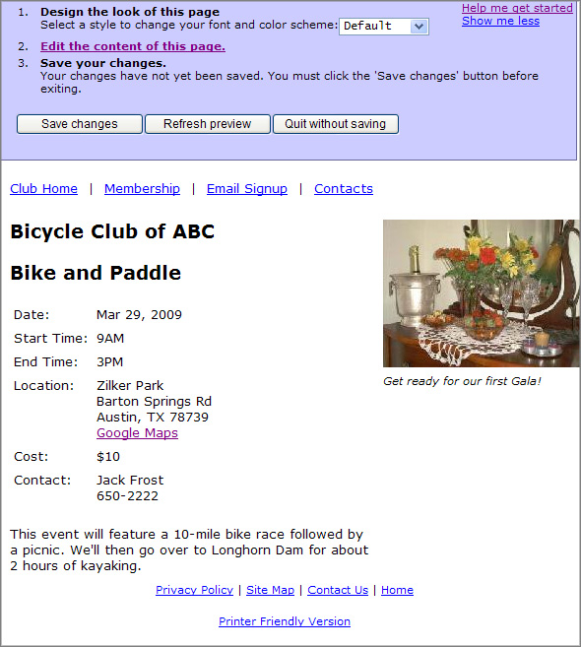

- Click Edit the content of this page in the Preview window to return to the Editing window if you wish to make more changes
Or,
Click Save changes to accept the page and then click Stop editing this page to return to the normal view of your site.
When you return to the normal view of your pages, you will see that your event is now listed (as a link) under the Event Pages heading. You will also see a View all link that will display all of your events in calendar view as shown below. Note that this link with calendar view is also available to your members.

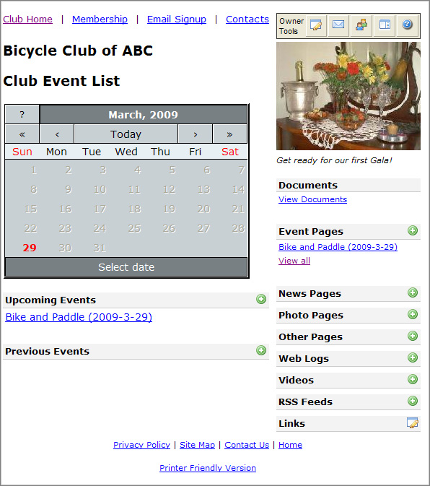
Adding a News Page
A News page is very similar to your Home page, except that you can choose to delete a news page at any time.
To set up a news page:
- Click the Add News icon next to the News Pages heading on your page wrapper.
- On the editing page that opens (shown below), enter a Headline for your News Article. (The headline text will also become the link to the page on your wrapper.)

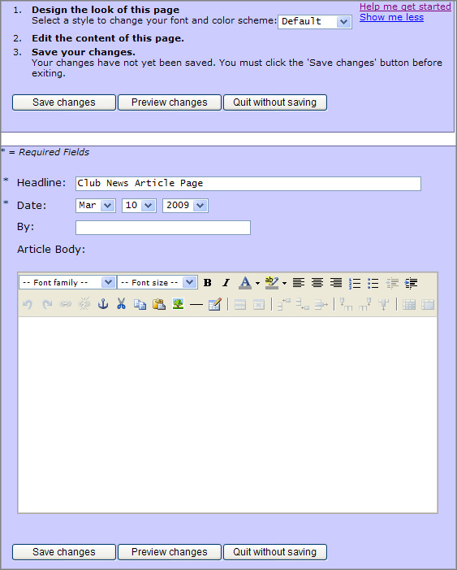

- Enter the Date of your article by selecting from the drop-down menus for the Month, Day, and Year.
- Enter a Byline (the person who wrote the article).
- Type the Article Body in the space provided.
- Click Preview changes to view the proposed News page. Your page might look something like the following:

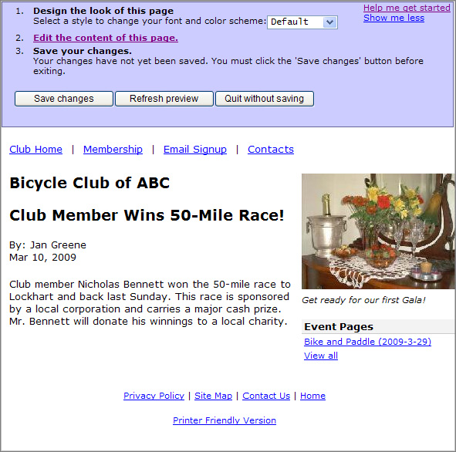

- Click Edit the content of this page in the Preview window to return to the Editing window if you wish to make more changes,
Or,
Click Save changes to accept the page and then click Stop editing this page to return to the normal view of your site.

Adding a Photo Page
A Photo Page allows you to share photos of your activities with your members. Each photo page can contain several photos (in jpg, gif, or png format) and you can add as many photo pages as you like. Once you have created a photo page and uploaded the photos, your members will see small images called thumbnails; they can then click the thumbnails to see the full-sized photos in a new window. They will also be able to view the photos as a slide show.
Note: A Photo page can be deleted at any time.
To create a Photo page:
- Click the Add Photo Page icon next to the Photo Pages heading on your page wrapper.
- In the editing window that opens, choose a style to change your font and color scheme if desired.
- Provide a Title for your album.
Note: This title will appear at the top of your album (photo page) and will also appear on your page wrapper as a link to your album.
- Describe the photo album. (See Using the TinyMCE Editor if you need help with the editing tools.)
- Enter a Display Width in Pixels if you would like to control the display size of the photos in this album; otherwise, they will display full size.
- Browse to locate and Open the first photo for the album. The file path will appear in the Filename field for Photo 1.
- Provide an optional Title and Story for the Photo.
- Click Preview Changes to see how your photo will display.
- Click Edit the content of this page to return to the editing page for the album. The editing page will now display a thumbnail version of your first photo – and a Delete button that allows you to remove that photo if you wish. The first portion of the editing page is shown below:
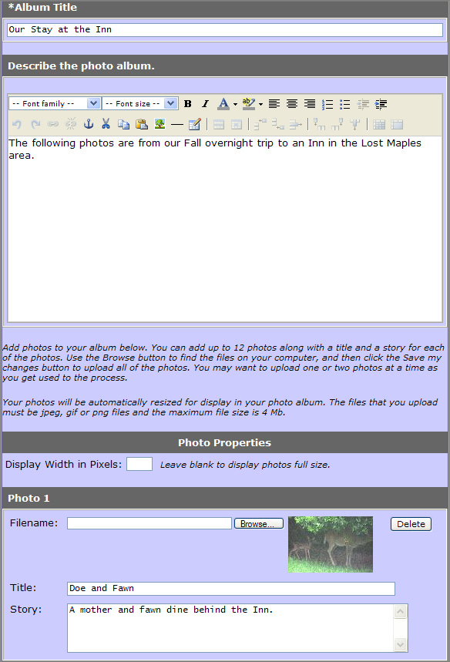
Provide an Album Title
Describe the Album
Add a Title and a Story for the Image
Upload an Image
Note: Clicking the thumbnail version of a photo on the editing page will allow you to see the full-sized image.

- Follow the same steps to upload additional images, clicking Preview changes at any point to see the proposed album. Your preview window might look something like the following after adding four images:

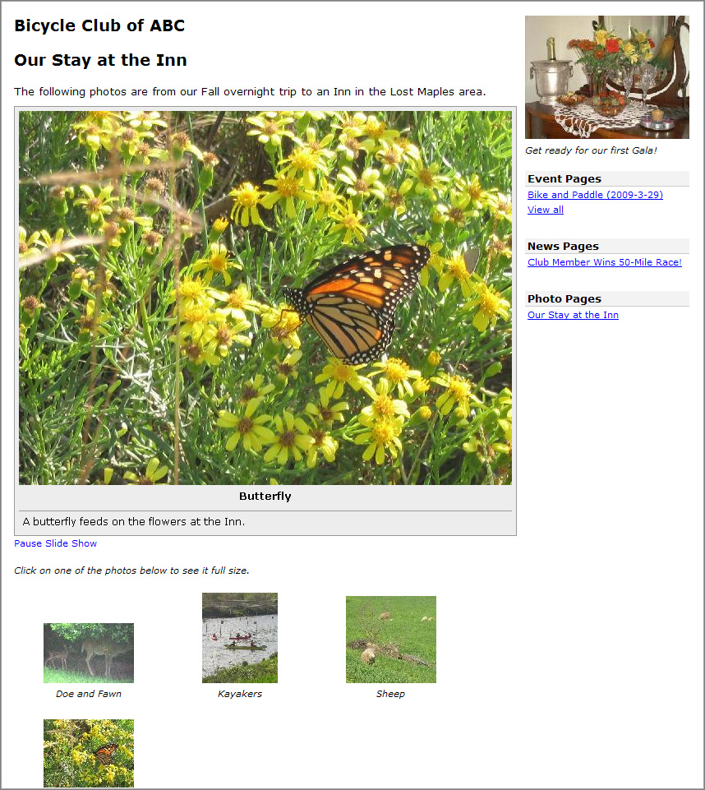

Note: The album preview opens as a slide-show – just as it will for your members. However, both you and your members can Pause the slide show and simply view the full-sized images by clicking on the thumbnails.

- Click Edit the contents of this page in the Preview window to return to the Editing window if you wish to make more changes,
Or,
Click Save changes to accept the page and then click Stop editing this page to return to the normal view of your site. The photo album Title should now appear as a link under the Photo Pages heading. When visitors click one of the small images on your photo page, the larger version of the image will open in a new window.

Adding an “Other Page”
“Other Pages” allow you to share miscellaneous stories with your members (items that may not fall in the preceding categories). You can include up to two headlines with stories on each single page and you also have the ability to select a layout that will include a photo. These pages can be deleted at any time.
To create an Other Page:
- Click the Add Other Page icon next to the Other Pages heading on your page wrapper.
- On the editing page that opens, select a Layout Template for your page. Options include Photo Right, Photo Left (as shown below), or Standard (no photo).

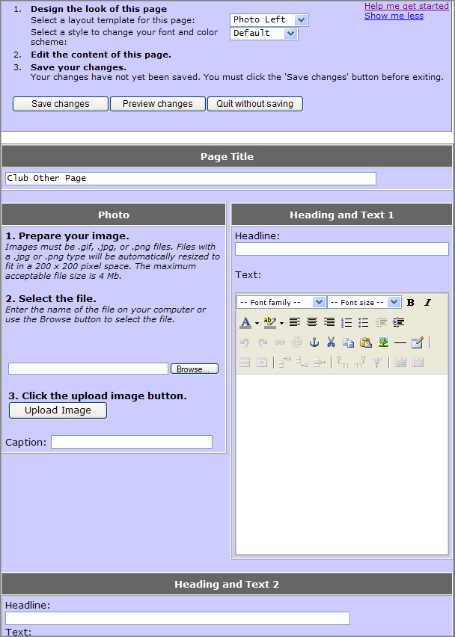
Provide a Page Title
Provide the content of your first article
Add a Photo – if you have selected a Photo Layout
Provide a Heading for your first article
Select a Style
Select a Layout

- Optionally, select a Style to determine your font and color scheme.
- Type in a Page Title (for example, “Member Stories”).
- Type a Headline for the first item (for example, “Paul’s Disaster”).
- Type the Text for the first item.
- Repeat steps 5 and 6 to add an additional item.
Note: If you are using the Standard layout, you will need to select the link titled Click here for an additional set of input fields to access the second headline and text entry fields.
- Add a Photo if you have selected a Photo Left or Photo Right layout, using the Browse and Upload procedure discussed previously in this document.
- Click the Preview changes button at the top of the page to see how your page will look. Your preview might look something like the following:

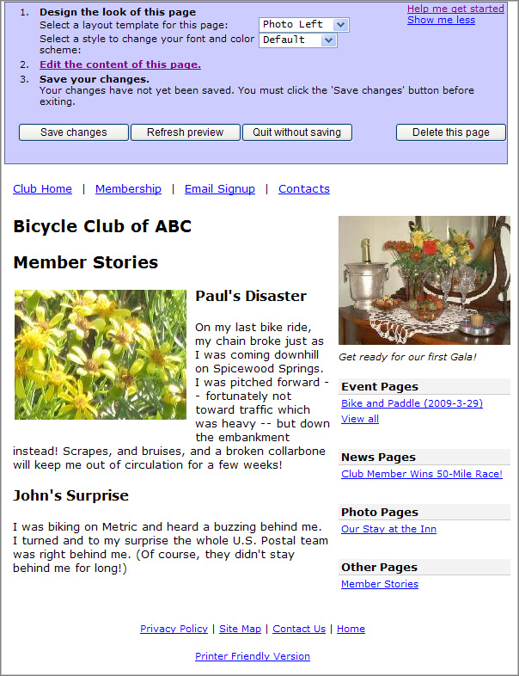

- At the top of the preview page, choose Edit the content of this page to return to the editing page and continue to add or change content,
Or,
Click Save changes to accept the page and then click Stop editing this page to return to the normal view of your site. The page title should now appear as a link under the Other Pages heading.

Editing Pages
You can edit a page at any time simply by selecting the page and clicking the Edit This Page icon in your Owner Toolbar.
To edit a page:
- Select the page you want to edit (that is, be sure you are viewing the page).
- Click the Edit This Page icon in your Owner Toolbar to open the editing window where you created the page.
- Make any changes, previewing as you go.
- Click Save changes to accept your changes and then click Stop editing this page to return to the normal view of your site.
Important: If your site is “live”, your members will continue to see the existing version of the page until you Save the new version.

Deleting Pages
You can delete any page except the Home page, the Membership page, the Email Signup page, and the Contact page.
To delete a page:
- Select the page you want to delete (that is, be sure you are viewing the page).
- Click the Edit This Page icon in your Owner’s Toolbar to open the editing window where you created the page. A sample window is shown below:

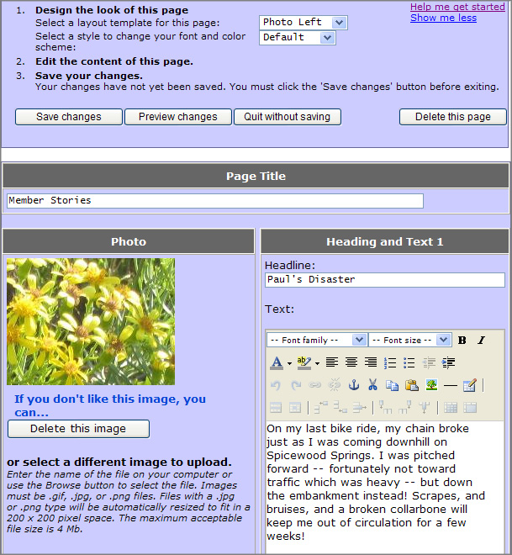
Click the “Delete this page” button

- Click Delete this page at the top of the window. You will be asked to confirm the deletion with the following prompt:

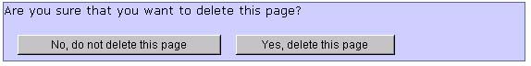

- Click Yes, delete this page to remove the page and return to the normal view of your site.

Adding and Editing Links
You can add links from your site to other sites. The links will appear as highlighted text beneath the Links heading on your wrapper. Links can take members back to specific pages for your sponsoring organization or to other web sites.
Adding a Link
Add a link as follows:
- Click the Edit Links icon next to the Links heading on your wrapper to open the Links editing page shown below:

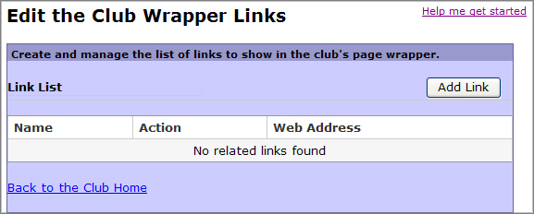

- Click the Add Link button to open the New Link screen:

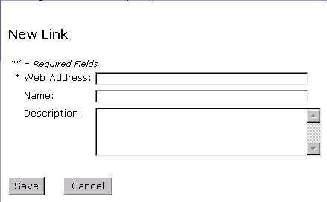

- Enter the following information for your link:
- Web Address: the complete URL for the site (for example, http://www.convio.com)
- Name: the wording that your members will click to follow the link (for example, “Convio”)
- Description: describes your link, but will not appear on your page (for example, “the company that powers our site”).
- Click Save to return to the editing page.
- Click Back to the Club Home to return to the normal view of your site. The Name of the link will now appear under the Links heading on your wrapper.
Important: Be sure and test your link after you create it. Links will open in the same window so use the ‘Back’ button on your browser to return to your Club pages.

Editing a Link
If you decide you want a different Name for your link or if the link doesn’t work, you can edit the link as follows:
- Click the Edit Links icon next to the Links heading on your wrapper to open the Links editing page shown below:

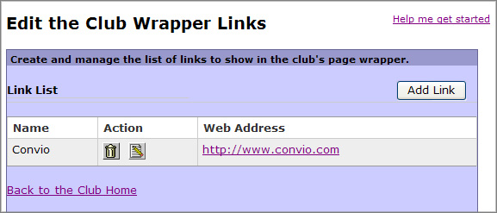
Click the Pencil icon to edit a link

- Click the Edit icon (the pencil) in the Action column beside the Name of your link to open the Edit Link screen for your specific link:

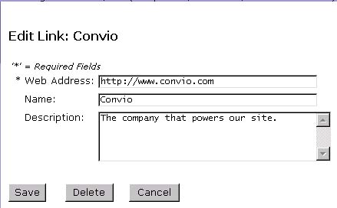

- Make any changes (for example, make the name more descriptive).
- Click Save to return to the Link List.
- Click Back to the Club Home to return to the normal view of your site.

Deleting a Link
If you no longer need or want a particular link, you can delete it as follows:
- Click the Edit Links icon next to the Links heading on your wrapper to open the Links editing page shown below:

Click the Trashcan icon to remove a link

- Click the Delete icon (the trash can) in the Action column beside the Name of your link to remove the link.
- Click OK to confirm the deletion.
- Click Back to the Club Home to return to the normal view of your site. The link should no longer appear on your wrapper.

Managing Membership Information
If your club has chosen to use a membership form, then you will see a membership link at the top of your pages. When visitors click on the Membership link, they will see information about joining your club. You may be responsible for providing and updating some of the information on this page—although the actual membership roster will be maintained by your parent organization.
When you click the membership link, your initial view of the page should be something like this:

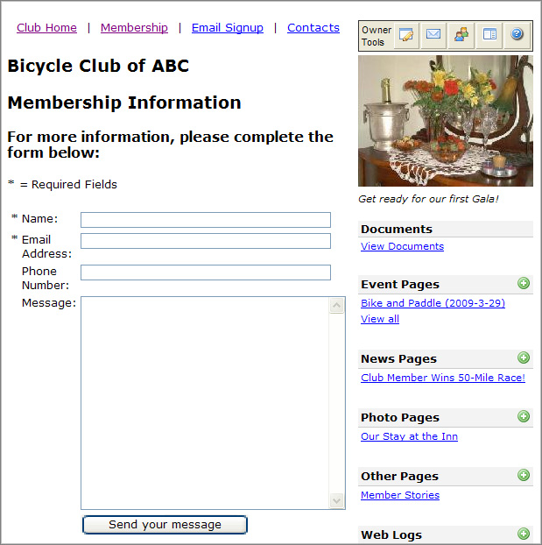

A potential club member can complete the membership form—providing Name, Email, and an optional Phone Number and Message—and then click Send your message; the message will be sent to the site administrator for your sponsoring organization who will then add the individual to your membership group. (All members of your owners group will also receive the email request.) If there is no fee for membership, you may choose to leave the form just as it is.
If you have a membership fee and/or any other special instructions you wish to convey, you can edit the membership page as follows:
- Click the Membership link at the top of any of your pages to view the current membership information.
- Click the Edit this Page icon in your Owner’s Toolbar to open the editing page for membership as shown below:

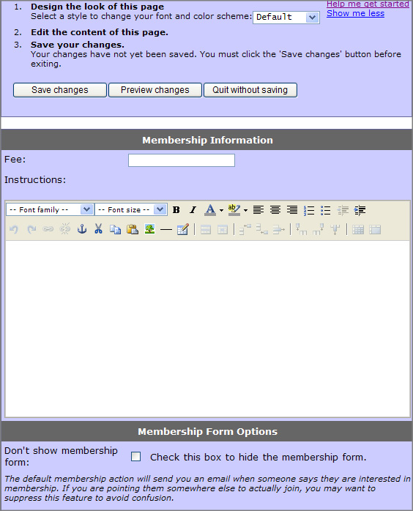
Enter a membership fee, if applicable
Provide special instructions, if applicable
Check this box to hide the membership form, if desired

- Select a style for your font and color scheme from the drop-down menu at the top of the page.
- Provide any Fee in the box provided.
- Provide any special Instructions in the text editing area. (For example, you might insert a fee and then, under instructions, you might add, “Make checks payable to Bicycle Club of ABC and mail to Bill Smith at 12 Roxbury Lane, Austin, TX 78730. Please also submit the email below.”)
- If you are directing your potential members to submit their application elsewhere (for example, if you are directing them to your parent Web site), optionally check the option box that will hide the membership form on your club site to avoid possible confusion.
- If you are using PayPal Integration, check the Yes, use PayPal box (not shown above) and complete the requested fields if you would like to use your PayPal account to accept membership fees. (See the last section of this document for more information.)
Note: The PayPal Integration fields will only appear if your parent organization has decided to make this option available. Most clubs will not see this option.
- Click Preview changes to view the proposed membership page. It might now look something like the following:

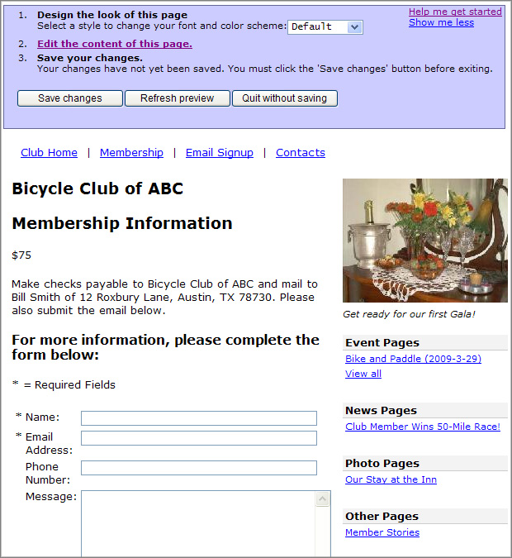

- At the top of the preview page, choose Edit the content of this page to return to the editing window and continue to add or change content,
Or,
Click Save changes to accept the page and then click Stop editing this page to return to the normal view of your site.

Managing Email Signup
Once your Club becomes available to your members, you will have access to your membership group and be able to send email to them. For this reason, the Email Signup page for your club is intended more to allow those who are not actually members of your club to sign up for your email communications. Since you can configure the Page header and Page Footer on the Email signup page, you may want to add text encouraging non-members to sign up for your club mailings.
Those who sign up for email communications using your email signup page will become members of your email Subscriber’s group. If you get a verbal or written request, you can also add to your Subscriber’s group using your owner’s version of the email signup page.
Note: This feature may not be available for some clubs.
To configure the Email Signup page:
- Click the Email Signup link at the top of any of your pages to view the current signup page.
Important: The operation of the email signup page is different for end users vs. club owners. For club owners, the screen only presents the name and email fields. As an owner, you can add someone to your subscriber group using this page (creating a new constituent if necessary), but you cannot change any information about existing constituents. End users, on the other hand, will have a standard registration form requiring name and email and asking for a full address.
- Click the Edit this Page icon in your Owner’s Toolbox to open the Edit Club Email Signup Page window shown below:
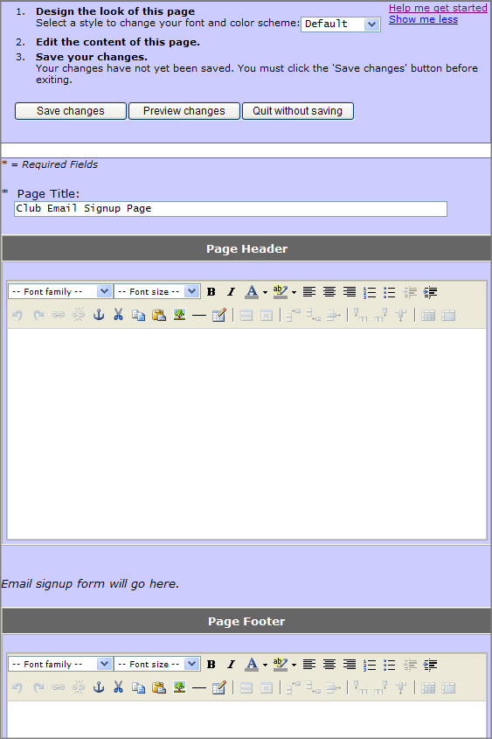

- Optionally, select a Style to change the font and color scheme of the page.
- Optionally, modify the Page Title.
- Enter text into the Page Header section if you would like to introduce the form.
- In addition, or as an alternative, enter text into the Page Footer section that also clarifies the purpose of the form.
- Click Preview changes to view the proposed Email Signup page. Your preview (if you have added some introductory Header text) might look something like the following:
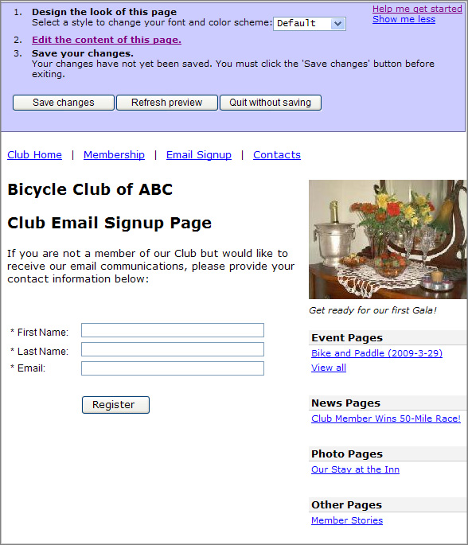
- At the top of the preview page, choose Edit the content of this page to return to the Edit Email Signup window and continue to make changes,
Or,
Click Save changes to accept the page and then click Stop editing this page to return to the normal view of your site.
To use the Email Signup page to add constituents to your Subscribers Group:
- Click the Email Signup link at the top of any of your pages to view the signup page.
- Enter the constituent’s First name, Last name, and Email address.
- Click Register. You will receive a message that verifies that the constituent has been successfully registered to receive email updates from your club.

Managing Contact Information
The contact information page for your club should contain the names and contact information for those members of your club that other members may want to reach. These members may include the following: the Club President, you as the Web Master, and any other members you wish to designate. Again, you will be responsible for adding and updating this information.
To add or change the contact information:
- Click the Contacts link at the top of any of your pages to view the current contact information. (If this is the first time you are viewing this page, there should be very little on the page except the ‘Contact List’ heading.)
- Click the Edit this Page icon in your Owner’s Toolbox to open the Edit Contacts window shown below:

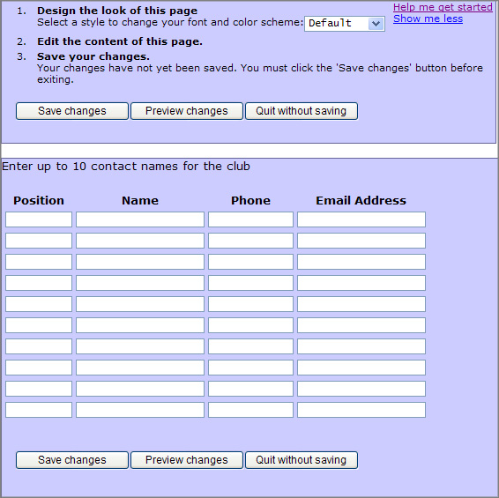

- Select a Style to change the font and color scheme on this page, if desired.
- Provide contact information in the boxes supplied.
- Click Preview changes to view the proposed contact page. Your preview might look something like the following:

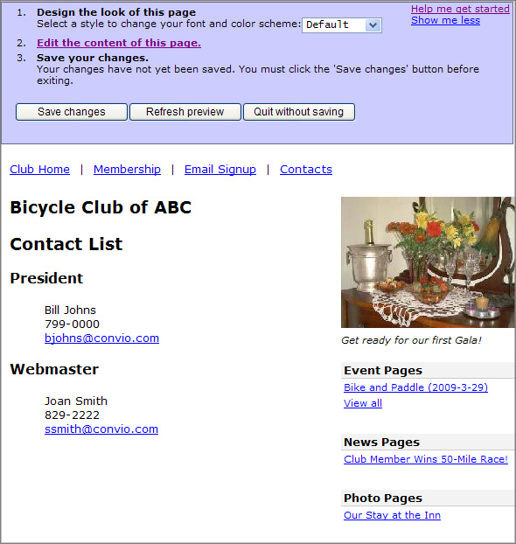

- At the top of the preview page, choose Edit the content of this page to return to the Edit Contacts window and continue to make changes,
Or,
Click Save changes to accept the page and then click Stop editing this page to return to the normal view of your site.

Going “Live” with your Club Pages
When you have set up the Home page, the Contact page, the Membership page, and any other pages you wish to set up initially, you should contact the site administrators for your sponsoring organization—probably by email or by phone—to let them know that your club pages are ready to “go live”. The administrators will then provide a link to your Club – probably from the main pages of the organization -- so that club members and visitors can find your club pages.

Sending an Email
Once your club pages have gone live and are available to your members, you will be able to send email to your members using the Send Email icon on your Owner’s Toolbar.

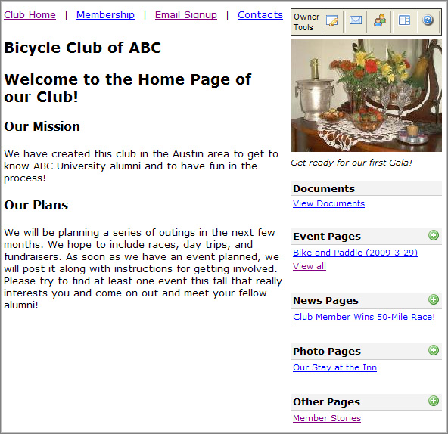
New icon appears for sending email

In fact, you may wish to send an email soon to let your members know your club is now online.
To send an email:
- Click the Send Email icon that now appears in the upper right portion of your wrapper to open the Send Email page shown below.

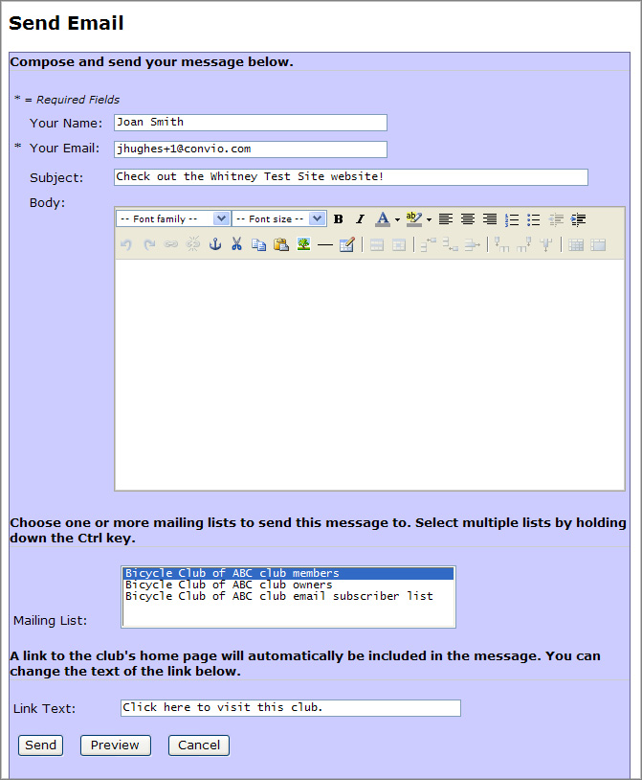

- Change the Subject for your email if you would like (for example, Bicycle Club of ABC now Online!)
- Type a message Body using standard message formatting.
- Choose one or more Mailing Lists to send this message to. Your choices will include the List of Club Members, the List of Club Owners, the List of Club Subscribers, and any other lists to which your parent organization may have granted access.
Note: Select multiple lists by holding down the Ctrl key as you make your selections.
- Type Link Text for the link to your club site that will automatically be inserted in your message, if you would like to replace the default text. (For example, you might type in “Click here to go directly to our Club Pages.”)
- Click Preview to see how your message will appear to your audience, closing the preview window when finished.
- Click Send. You will receive the following confirmation:

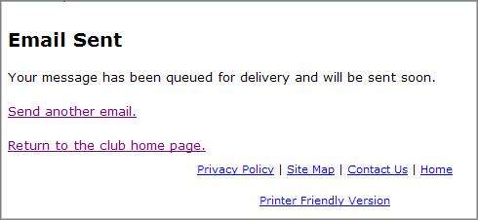

- Click Return to the club home page to return to the normal view of your club pages.

Managing Mailing Lists
Initially, you will have three lists available when sending email -- the Club Member list, the Club Owner list, and the Club Subscriber list. In addition, the administrator of your sponsoring organization may allow you to contact additional lists of individuals (for example, the list of those individuals who responded to a recent survey in your area). Although you can now select multiple lists when sending an email, you may still wish to combine various lists for email purposes.
This section explains how to create a new list from your existing lists, how to edit a list, and how to delete a list you no longer need. It also explains how to edit the Unsubscribe List of members who do not wish to receive Club email and how to run a Membership Report.
Creating a New List
Create a new list for email purposes as follows:
- Click the Manage Mailing Lists icon that appears in the upper right portion of your wrapper to open the Mailing List Management screen.
- Click Create a New Mailing List.
- On the screen that opens, provide a List Name.
- Click Save. You will return to the Mailing List Management screen.
- In the View an existing list section of the page, click on the name of your new list.
- On the screen that opens, click Manage members of this list.
- On the Manage List Members screen that opens, build your new list as follows:
- Select an Existing Group from the drop-down menu.
- Click Choose Group to display the members of this group in the box to the left of your screen as shown below:
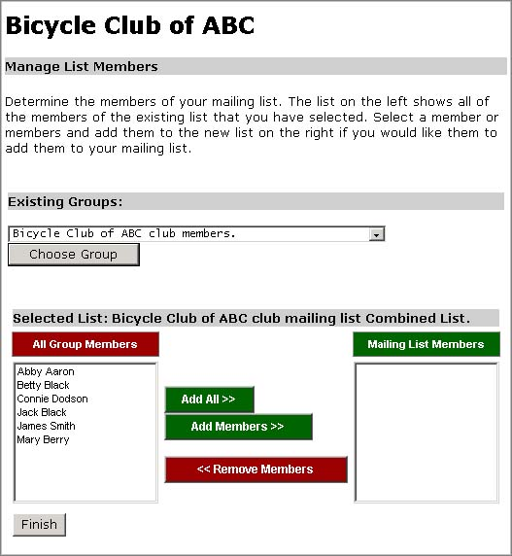
Highlight members in the box at the left and click Add Members to place them in your new Group
Click the Choose Group button to display the Group Members below
Select an existing group from the drop-down menu
- Highlight those members of the group that you would like to add to your new list.
- Use the Add Members button to add those members to your new list (displayed in the box at the right of your screen).
Note: You can remove members from the new list by highlighting their names on the new list and clicking the Remove Members button.
- Repeat this process to add members from another Group.
- When all members have been selected, click Finish. The new list will now be available in the drop-down List on the Send Email screen.

Editing a List
Important: You will not be able to edit the default Member, Owner, and Subscriber lists.
Add or remove members from an existing list as follows:
- Click the Manage Mailing Lists icon on your wrapper.
- Click the link for the Existing List you would like to edit.
- On the screen that opens, click Manage members of this list.
- Make changes to the list using the same procedure (discussed above) that you used to create the list.

Deleting a List
Important: You will not be able to delete the default Member, Owner, and Subscriber lists.
Delete a list you no longer need as follows:
- Click the Manage Mailing Lists icon on your wrapper.
- Click the link for the existing List you would like to delete.
- Click Delete this list.
- You will be asked to confirm the deletion. Click Delete to complete the process and return to the Mailing List Management page. The list will no longer appear in the drop-down menu on your Send Email page.

Editing the Unsubscribe List
Individuals who receive your club email messages can request that they be removed from your mailing list. Members (or other recipients) can request that they be removed themselves through an Unsubscribe link that will automatically place them on your Unsubscribe List. As an owner, you can also manage the Unsubscribe List by adding or removing members. (Note that the site administrator of your parent site can also add and remove members from this list.)
Edit the Unsubscribe List as follows:
- Click the Manage Mailing Lists icon that appears in the Owner’s Toolbar to open the Mailing List Management screen.
- Click Edit the Unsubscribe list.
- On the screen that opens, select any club member in the box at the left of the screen that you would like to remove from the club mailing list.
- Click Add Members to move that individual to the Unsubscribed Members list at the right of the screen. (Conversely, if you have received a request to return a member to your club mailing lists, you can select an individual from the Unsubscribed Members list and move them back to the list at the left.)
- Click Finish to complete your changes. Anyone that you have placed on the Unsubscribed Members list will no longer receive any club mailings.

Running a Membership Report
If you need a list of all club members, owners, and subscribers, you can run a membership report. This report will include addresses and phone numbers, if available, and is accessed through the Mailing List Management area.
To run a Membership Report:
- Click the Manage Mailing Lists icon that appears in the Owner’s Toolbar to open the Mailing List Management screen.
- Click Run Membership Report. The page will refresh and display a list of your Club Owners, Members, and Email Subscribers. A sample of this report is shown below:
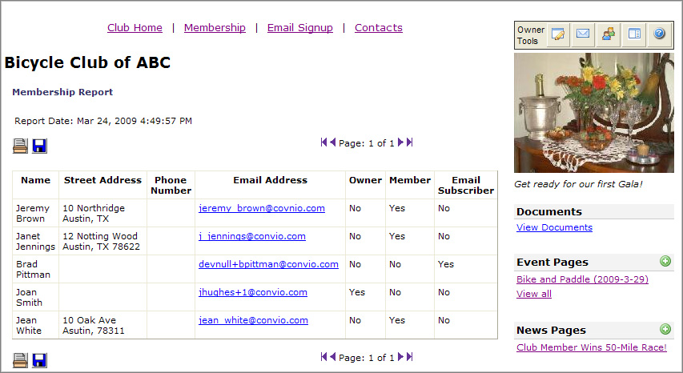

Uploading Documents
Note: Not all Clubs will have this feature. If you do have the ability to upload documents to your site, you will have a heading on your wrapper called Documents and a link directly beneath it called View Documents.
The Document Upload feature may be used to upload most types of documents to your site. Your members may then open and view the documents if they have the software with which the document was created or a suitable substitute. They can also download or print the documents. This feature may be useful for distributing rosters or long documents, forms to be printed and signed, directions to activities, and more. Most types of documents can be uploaded except Microsoft™ executables (.exe), which are blocked to protect your site from viruses.
Both you and your members will access the Document upload page by clicking the View Documents link on your wrapper. You will have the same view of the page as your members do, except that you will have an additional area for uploading the documents.
Note that the site administrator of your sponsoring organization will be notified whenever you upload a document and will have editing privileges.

Editing the Document Page (optional)
If you would like to select a style for the document page or add an introduction to your document list, then use this section. Otherwise, go directly on to “Uploading a Document.”
Make optional changes to your Document Upload page as follows:
- Click the View Documents link on your wrapper to open the Document Upload page.
- Click the Edit This Page icon (the same icon you use to edit all pages) to open the editing screen.
- Select a style for the font and color scheme of the page if that option is available and you do not wish to use the default style.
- Alter the Page Title for the Documents section, if you wish.*
- In the Document List Area, enter an Introduction to the List message, if you would like, as shown below:

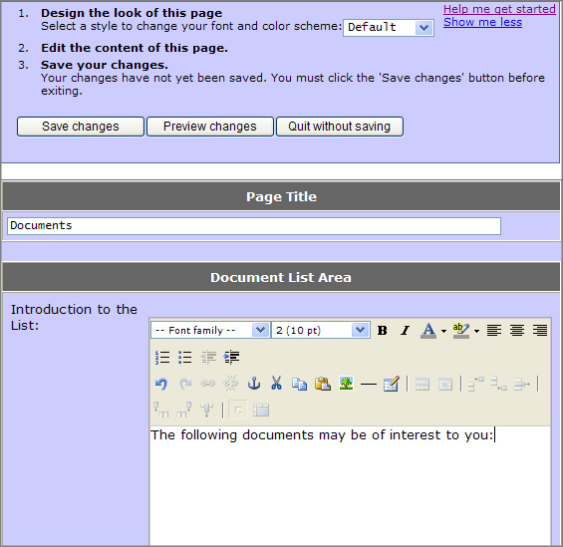

- Click Preview changes (or return to Edit the contents of this page to make additional changes).
- Click Save changes.
- Click Stop editing this page to return to the normal view of the Document upload area.
Important: If you choose to change the Title of the Documents page, be sure to change the name of the page and link text on the wrapper so that everything matches. (To change the name of the page and link text on the wrapper, click the Edit Wrapper icon on the Owner’s Toolbar.)

Uploading a Document
Upload a document to your site as follows:

- Click the View Documents link beneath the Documents heading on your wrapper (if you are not already viewing the Documents page).
- On the Documents page, provide the following:
- Document Title: for example, “Sign-up Form for Picnic”; this name can be the same as the file name, but does not have to be
- Description: a description of the document or the purpose of the document; for example, you might describe what the member should do with the “Sign-up Form for the Picnic”; may be up to 255 characters
- Use the Browse button to locate and Open the file you wish to upload. At this point, your screen might look something like the following:

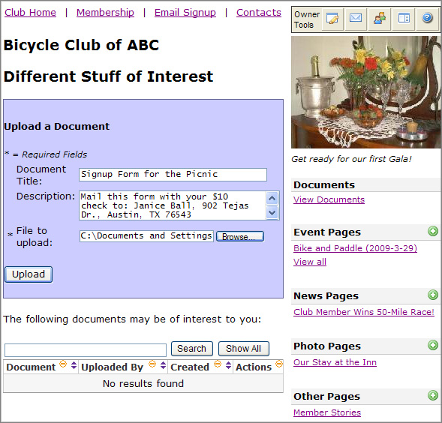

- Click the Upload button. The file will appear in the document list below the upload area as shown:
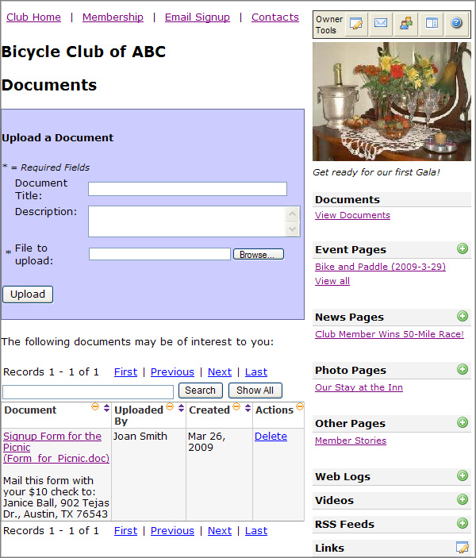
Document Title and File Name are both included in the link to the document.

The description is included below the link.

Note: Members will see the same list when they click the View Documents link, except they will not have the Actions column.

Testing the Upload
Test your upload to be sure the link is working and the document is displaying correctly. The specific action you or a member will take to view or download the document will depend on the Browser in use.
- Click the new link you have just created (which includes the Document Title and the File Name). The following options are available when you right-click the link using Internet Explorer on a PC:
- Open
- Open in New Tab
- Open in New Window
- Save Target As
- Print Target
- Open and/or download the document.
- Close the viewing window when finished if you have chosen to Open the document.

Viewing or Searching the Document List
Keep in mind the following factors when viewing the Document List or searching for a particular document:

- Use the arrows in each column to sort.
- Use the minus sign (-) in each column heading to collapse the column view (or the plus sign to re-establish the column)
- Enter the document Name or Description (or a portion of either) and press Search to locate a specific document.
- Press Show All to see the complete list.
- If your sponsoring organization has limited the number of documents you can upload, note the following message in your upload area when your limit has been reached,

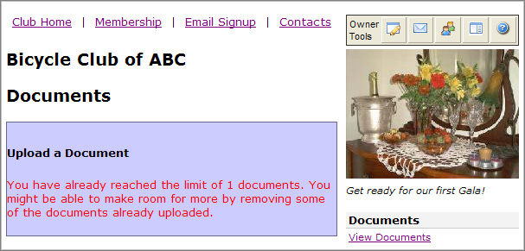

Deleting a Document
When a document is no longer needed, delete the document as follows:
- Click the View Documents link on your wrapper.
- Locate the Document in your list.
- Click the Delete link in the Actions column beside the Document you wish to delete.
- In the confirm box that opens, click OK to remove the document from your list.

Using a Web Log
A Web Log discussion board, when incorporated into Club pages, allows a Club Owner to initiate an interactive discussion with members. The Owner creates a new Web Log and then posts a Topic to that log, providing a little background—and possibly including a link to a longer document.
Members of that Club can then view the Original Post and add comments of their own. All comments are attributed to the member who makes them; that is, no anonymous comments are allowed. (If the Club pages are open to non-members, those individuals, too, can view the Web Log and comments but may not add additional comments.) An Owner can edit or delete inappropriate comments and can even delete an entire Web Log if desired.
A Club may have multiple Web Logs (for example, a General Log, a Hot Topics Log, etc.); in fact, an owner may want to create logs in such a way that they can archive older discussions (for example, a January Log, a February Log, etc.). Each log can have multiple topics—and, of course, there may be multiple comments associated with each topic. Because logs can become complex, a Permanent Link feature allows both Owners and Members to create a link to a specific posting—possibly to add to a favorites list or to email to a friend.

Creating a Web Log
Note: If you would like to change the heading Web Logs on your wrapper (for example, to Discussion Topics or Blogs), choose the Edit the wrapper for all pages icon in the Owner’s Toolbox and make that change before you begin.
To set up a new Web Log:
- Click the Add Web Log icon next to the Web Logs topic on your wrapper. This action will open the Editing screen shown below:
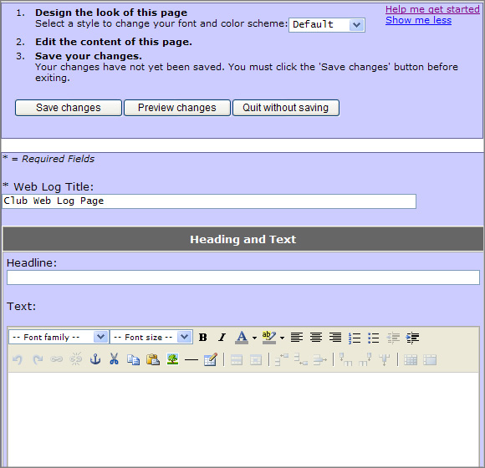

- Select a Style to change your font and color scheme for the page if desired.
- Enter a Web Log Title (for example, General Log).
- Enter a Headline (for example, Purpose of this Log).
- Enter Text to associate with this log (for example, explain the purpose of this particular log).
- Click Preview changes.
- Click Save changes (or choose Edit the Content of this page to make additional changes).
- After saving your changes, click Stop editing this page. The new log will appear in your list of Web Logs and you will have an active link enabling you to Post a New Topic to your log as shown below:
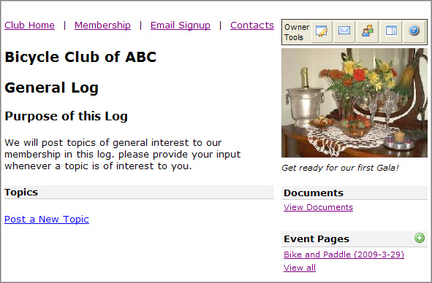

Posting a New Topic to a Web Log
Posting a new topic to a web log involves entering a subject and adding a bit of background or a link to more information on that subject. Post a topic as follows:
- Click the Post a New Topic link.
- Enter a Subject (for example, Proposed New Biking Path).
- Add background material in the Body portion of the window, possibly including a link to a longer article. (See the screen capture below for an example).
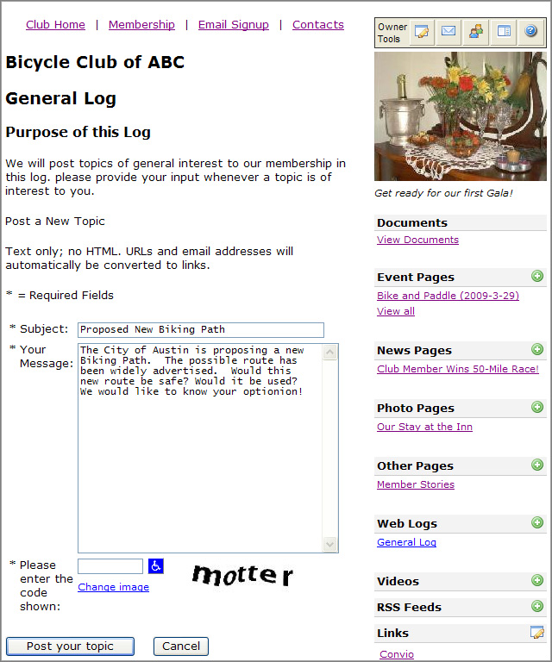

Note: The full http:// address must be provided for links. Also note that links will open in the same window for the user.
- Complete the CAPTCHA question, if present, by entering the bold text (motter in the example above) into the text box provided at the left. This step is provided to protect your club site by ensuring that posts are being made by humans and not by computers.
- Click Post your topic. Your topic will appear as the first Post beneath the Log Title, and your name and time of posting will appear immediately beneath the posting as shown:
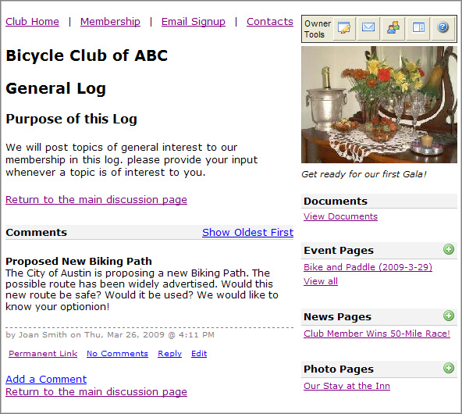

As an owner, you will now see the following links beneath the topic:
- Permanent Link – depending on your browser, you may be able to use this link to create a permanent link to this location in the log. For example, right clicking the link using Internet Explorer 7.0 on a PC allows you to add this location to your list of favorites. (The link is also available beneath each Comment, in case a particular comment catches your fancy.)
- No Comments – this link gives the number of comments associated with a topic, and may be clicked to display the comments if they are not already visible.
- Reply – may be used to add additional comments; serves the same function as Add a Comment in the Comments section of the page
- Edit – reopens the Topic window in editing mode, allowing changes
You and your members will also have the following link available:
- Return to the main discussion page – Closes any Comments and displays only the Topics associated with the Log.

Posting Additional Comments to a Topic
Once the web log has been created and a topic added, both owners and members have the ability to comment on that topic. Add comments as follows:
- Click Reply immediately beneath the Topic or click Add a Comment beneath the Comments heading. Both links open the screen for adding a comment as shown below:

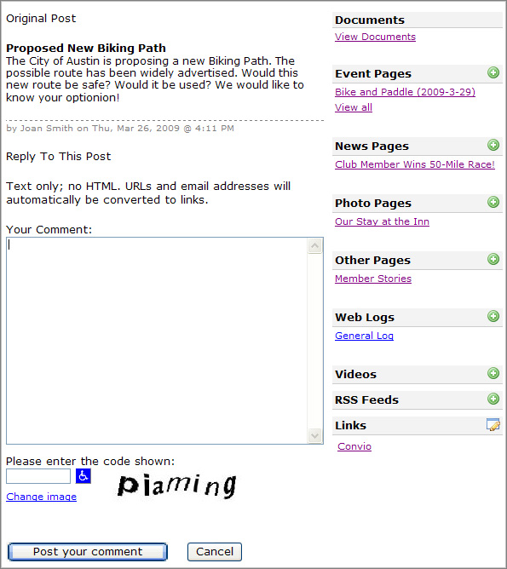

- Type Your Comment.
- Complete the CAPTCHA question if shown.
- Click Post your comment. The comment should immediately appear in the Comment section of the window as shown:
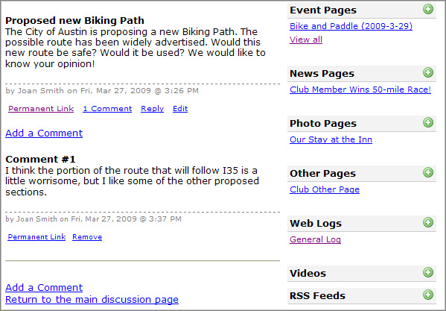

Removing a Comment
Owners have the ability to remove any comments that may be inappropriate. Remove a comment as follows:
- Click the Remove link immediately beneath the Comment you wish to remove.
- You will be asked to confirm the deletion. If you wish to proceed, click Delete. The comment will be replaced with default text as shown below:
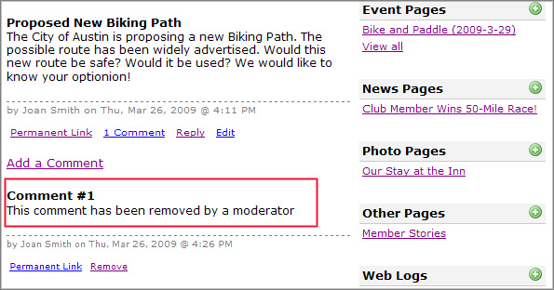
Deleting a Log
If you no longer need a log, you can delete the log and all of its associated topics and comments as follows:
- Click the link for the log you wish to delete—that is, be sure you are viewing the log.
- Click the Edit This Page link (the same editing link you use for all pages on your site).
- Click Delete this page.
- Confirm your deletion by choosing “Yes, delete this page.”

Adding a Video
If you have the Videos heading in your wrapper, you can make your club pages more interesting by adding one or more videos (flash movies). You can insert the URL for the Video Flash file directly, or you can search for YouTube Videos using keywords.
To add a Video to your club pages:
- Click the Add Video icon next to the Videos heading on your page wrapper.
- In the editing window that opens, select a style to change your font and color scheme if desired.
- Provide a Title for your Video page.
Note: This title will appear at the top of the page that holds your video and will also appear on your page wrapper as a link to your video page.
- Provide an introduction to your video in the Page Header section. (See Using the TinyMCE Editor if you need help with the editing tools.)
- In the Embedded YouTube Video section of the page:
- Indicate that you want to find the video on YouTube, and, in the expanded area of the page:
- Enter the URL of the YouTube Video, if you know it
Or,
Enter one or more search Keywords and/or the author of the video.
- Click Search YouTube. Videos that meet your search criteria will display in a Video Chooser pane. (Note that if you have entered a specific URL, only that one video will display in the Chooser.)
- Click on the video you want to display on your page and drag it into the Video Preview area.
- Play the video if you want to be sure you have the correct video.
- Drag a different video into the Preview area if you want to replace the original.
- Provide optional Page Footer text.
- Click Preview Changes to see how your video page will display. At this point your page might look something like the following:
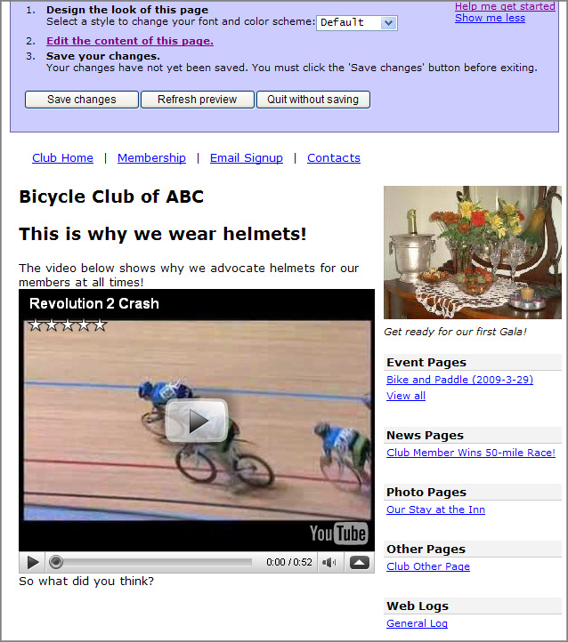

- Click Save changes (or choose Edit the Content of this page to make additional changes).
- After saving your changes, click Stop editing this page. The new video page will appear in your list of Videos on your wrapper.

Adding (and Deleting) RSS Feeds
If you use external tools for discussion forums or blogs, you can integrate the RSS feeds from those external tools into your club pages. You can also bring in RSS feeds from other sources such as news media if you find them relevant. Since each RSS Feed gets its own page, you can delete an RSS feed (if you no longer want it) by deleting the page.
Important: You will need the URL of your RSS feed before proceeding with the following steps.
To add an RSS feed to your club pages:
- Click the Add RSS Feeds icon next to the RSS Feeds heading on your page wrapper.
- In the editing window that opens, select a style to change your font and color scheme on this page, if desired.
- Provide a Title for this RSS Feed Page.
Note: This title will appear at the top of the page that holds your RSS feed and will also appear on your page wrapper as a link to this RSS feed page.
- Provide a Headline for this page.
- Provide a text introduction to your RSS feed. (See Using the TinyMCE Editor if you need help with the editing tools.)
- Provide the RSS Feed URL.
Tip: Often you must simply go to your blog or other feed source , right-click the orange XML button, select “Copy shortcut” or “copy target address”, and then paste that shortcut or address into the space provided on your club editing page.
- Select the Article Format from the drop-down menu provided. Choices include:
- Title and Description
- Title Only
- Title, Author, Date, Description
- Indicate the Number of Articles to Display. (The default number is 10, but you can replace the number). At this point, your RSS Feed editing page might look something like the following:
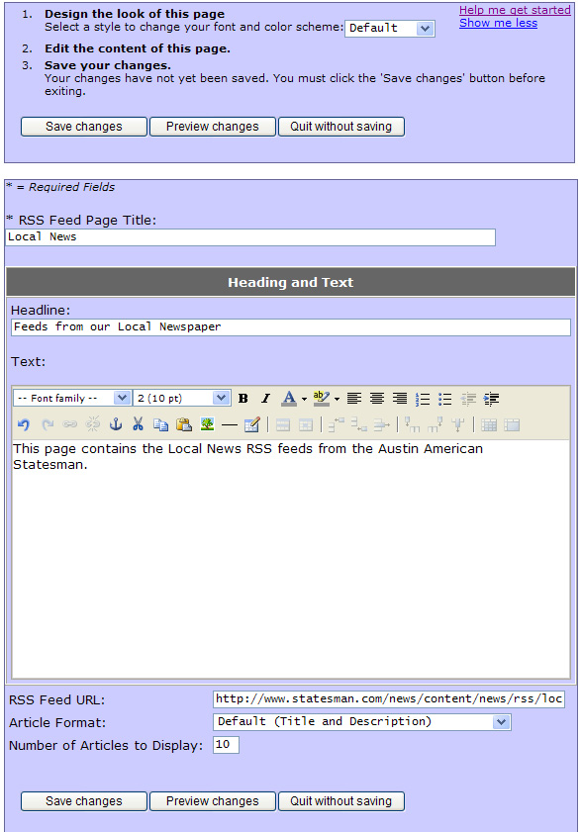
- Click Preview changes.
- Click Save changes (or choose Edit the Content of this page to make additional changes).
- After saving your changes, click Stop editing this page. The new RSS Feed page will appear in your list of RSS Feeds on your wrapper and might look something like the following:
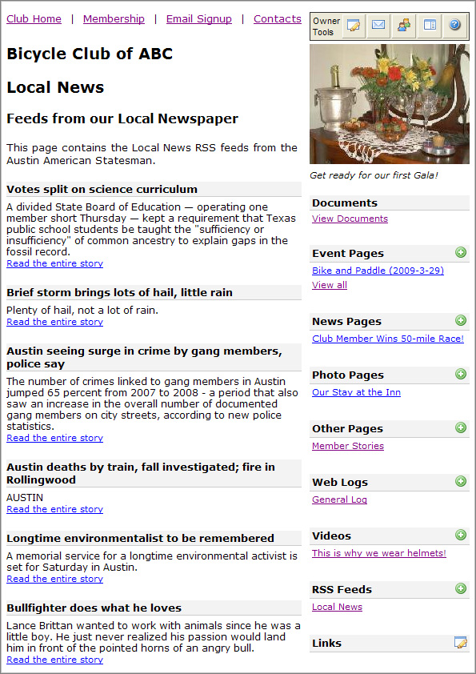

To remove an RSS feed from your club pages:
Note: Each RSS Feed gets its own page. If you want to delete a feed, you simply delete its page.
- Under RSS Feeds (on your page wrapper), click the Name of the feed that you want to delete. This action will display the feed page.
- In the Owner Tools section (above the list of pages), click the Edit this Page icon to re-open the editing page where this feed was created.
- In the top section of the editing page, click Delete this page.
- When asked to confirm, click Yes, delete this page.

Integrating with PayPal
If your parent organization has chosen to allow PayPal integration, you will have the option of adding a PayPal Buy Now or Donate button to your membership page and/or to event pages if you need to collect a fee. If you check the Yes, use PayPal option on these pages, you will be presented with the following screen:
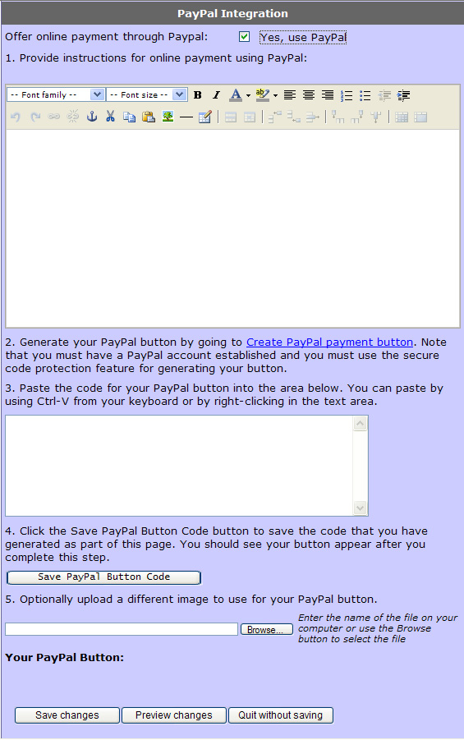
If you have this option, and choose to use it for membership or event fees, follow the onscreen steps to provide instructions to your members and generate the PayPal button. Note that you will need to establish your own club PayPal account

